Assignment 1 SQL Database Design and Implementation

itech 2004

Deepankar Rijal

30397109

Submitted to: Mohamad Naji

29 april 2023

2023

# **Executive Summary**

A customer uses the Manoosh Pizzeria's online ordering system to customise their pizza order, choose delivery, and pay for it in order to get ready for a gathering. The pizza ordering system is represented by 13 entities in the ERD, which are linked together for data management by relationships and attributes. Primary and foreign keys are used in the database design to preserve data consistency and avoid duplication, which makes it easier to track orders, customise them, offer promotions, and handle deliveries effectively.

Here are the key findings of the report:

* Data Consistency: Primary and foreign keys help to maintain data consistency.
* Order Tracking: Order tracking is enabled, and it is thorough.
* Customization: Customers have the option to customise orders.
* Promotions: Specific orders may be linked to promotional deals.
* Delivery Control: Effective delivery control is encouraged.
* Employee structure: Manager and employee entities specify the organisational structure.

Table of Contents

Executive Summary 1

1. ER Model 4

1.1 Scenario: An online pizza ordering system 4

1.2 Initial Entities 4

1.3 Normalization 5

1.4 Final Entities 6

1.5 ER Diagram 8

2. pgAdmin Screenshot 8

3. DDL Statements 9

3.1 customer 9

3.2 promotion 10

3.3 order 11

3.4 payment 12

3.5 ingredient 13

3.6 topping 14

3.7 pizza 15

3.8 pizzatopping 16

3.9 pizzaingredient 17

3.10 branch 18

3.11 employee 19

3.12 delivery_driver 20

3.13 manager 21

4. DML Statements 22

customer 22

promotion 23

order 24

payment 25

ingredient 26

topping 27

pizza 28

pizzatopping 29

pizzaingredient 30

branch 31

employee 32

delivery_driver 33

manager 34

5. Queries and Results 35

Query 1: Using INNER JOIN 35

Query 2: Using OUTER JOIN 36

Query 3: Using Specialization Hierarchy 37

Query 4: Using GROUP BY and HAVING 38

Query 5: Using INNER SQL Query 39

Query 6: Using UPDATE 40

References 41

Figure 1 3NF Normalization 7

Figure 2 ERD Model 9

Figure 3 Database Creation Image 1 9

Figure 4 Database Creation Image 2 10

Figure 5 DDL for customer Table 11

Figure 6 DDL for promotion Table 12

Figure 7 DDL for order Table 13

Figure 8 DDL for payment Table 14

Figure 9 DDL for ingredient Table 15

Figure 10 DDL for topping Table 16

Figure 11 DDL for pizza Table 17

Figure 12 DDL for pizzatopping Table 18

Figure 13 DDL for pizzaingredient Table 19

Figure 14 DDL for branch Table 20

Figure 15 DDL for employee Table 21

Figure 16 DDL for delivery_driver Table 22

Figure 17 DDL for manager Table 23

Figure 18 DML for customer Table 24

Figure 19 DML for promotion Table 25

Figure 20 DML for order Table 26

Figure 21 DML for payment Table 27

Figure 22 DML for ingredient Table 28

Figure 23 DML for topping Table 29

Figure 24 DML for pizza Table 30

Figure 25 DML for pizzatopping Table 31

Figure 26 DML for pizzaingredient Table 32

Figure 27 DML for branch Table 33

Figure 28 DML for employee Table 34

Figure 29 DML for delivery_driver Table 35

Figure 30 DML for manager Table 36

Figure 31 Query 1 37

Figure 32 Query 2 38

Figure 33 Query 3 39

Figure 34 Query 4 40

Figure 35 Query 5 41

Figure 36 Query 6 42

**1. ER Model**

## **1.1 Scenario: An online pizza ordering system**

In order to prepare for a gathering, a customer chooses to place an online order for a mouth-watering spread from Manoosh Pizzeria. They begin their culinary adventure by creating an account as a devoted customer on the Manoosh Pizzeria website. They select the substantial "huge" size to ensure there is plenty for everyone, choosing to savour the flavours of both the legendary "Super Supreme" and the classic "Margherita" pizzas.

Our customer creates their own unique pizzas by adding a variety of delectable toppings and well-chosen ingredients to the culinary canvas, creating a unique pizza experience. They choose the delivery option and carefully enter their address, leaving no possibility for delivery confusion, in order to make the evening hassle-free.

They head to the order summary page with their flawless pizzas in the virtual cart. Here, they determine the whole price by taking into account the base prices, alluring customizations, and small delivery costs. They confidently make their way to the cashier after being satisfied with their choices and the price.

They decide to use a credit card payment option because it is convenient at this key stage. They pay the invoice after safely entering their credit card information, completing the order process. Once the money has been accepted, an order is generated with a special order ID.

The order is quickly forwarded to the closest Manoosh Pizzeria location, where the capable branch manager receives it. The branch manager quickly assigns the duty to a devoted delivery driver who is in charge of making sure that this culinary treasure arrives on time.

The delivery driver gets ready for the trip as the pizzas are painstakingly made in the restaurant's kitchen. Armed with the customer's address and the order information, they make their way through streets and traffic determined to deliver the pizzas on schedule and in perfect shape.

As the delivery driver approaches the customer's doorstep, the decisive moment occurs. They hand the highly anticipated consumer a hot pizza after double-checking the delivery address. The consumer takes the purchase with a delighted smile, signalling the successful conclusion of an easy online ordering process.

## **1.2 Initial Entities**

1. **Customer:**
   * Attributes:

**cust_id** (Primary Key), cust_fname, cust_lname, cust_address, cust_phone, cust_email

1. **Order:**
   * Attributes:

**order_id** (Primary Key), order_date, total_amount, *cust_id* (Foreign Key), *promotion_id* (Foreign Key)

1. **Pizza:**
   * Attributes:

**pizza_id** (Primary Key), pizza_name, description, price, topping_id, top_name, top_price, ingredient_id, ing_name, ing_price, *order_id* (Foreign Key)

1. **Payment:**
   * Attributes:

**payment_id** (Primary Key), pay_date, amount, pay_method, *order_id* (Foreign Key)

1. **delivery_driver:**
   * Attributes:

**emp_id** (Primary Key), license_num, *order* (Foreign Key)

1. **branch:**
   * Attributes:

**branch_id** (Primary Key), branch_name, location

1. **employee:**
   * Attributes:

**emp_id** (Primary Key), emp_fname, emp_lname, position, salary, emp_phone, *branch_id* (Foreign Key)

1. **manager:**
   * Attributes:

**emp_id** (Primary Key), emp_fname, emp_lname, join_date

1. **promotion:**
   * Attributes:

**promotion_id** (Primary Key), promo_name, description, discount_percent, start_date, end_date

## **1.3 Normalization**

**1NF**

All the initial entities are in 1NF as:

* There exists primary key in every entities.
* There is no multivalued attributes

**2NF**

All the initial entities are in 2NF as there is no existence of partial dependency in any table.

**3NF**

All the initial entities are in 3NF except pizza as there is no existence of transitive dependency.

For pizza entity, we normalise the table into 3NF as shown in the picture:

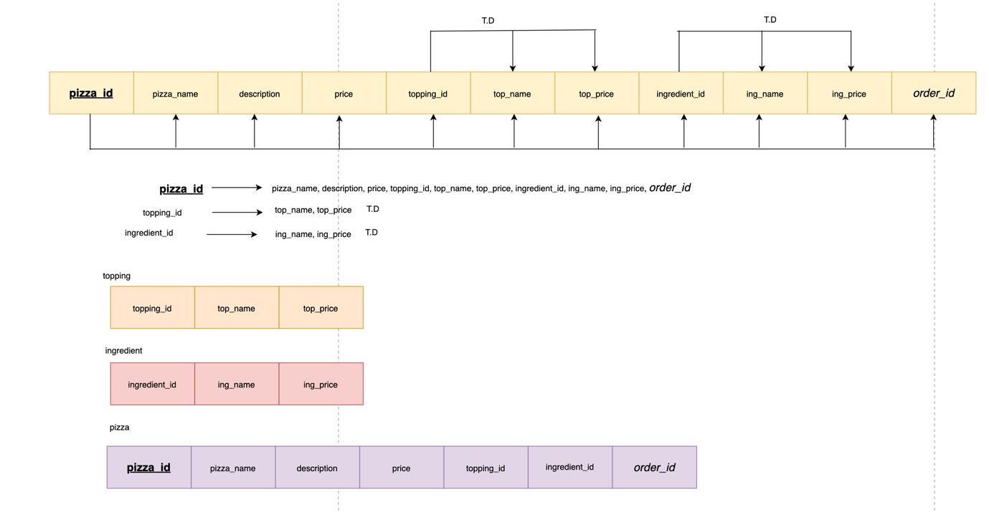

Figure 1 3NF Normalization

Here, 3 tables are created out of 1 pizza table after normalization into 3NF.

## **1.4 Final Entities**

In the final entities, I have categorized branch as supertype and delivery_driver and manager are subtypes of branch entity. Also, delivery_driver and manager are overlapping subsets (Zainurrohman, 2021).

1. **customer:**
   * Attributes:

**cust_id** (Primary Key), cust_fname, cust_lname, cust_address, cust_phone, cust_email

1. **promotion:**
   * Attributes:

**promotion_id** (Primary Key), promo_name, description, discount_percent, start_date, end_date

1. **order:**
   * Attributes:

**order_id** (Primary Key), order_date, total_amount, *cust_id* (Foreign Key), *promotion_id* (Foreign Key)

1. **payment:**
   * Attributes:

**payment_id** (Primary Key), pay_date, amount, pay_method, *order_id* (Foreign Key)

1. **topping**:
   * Attributes:

**topping_id** (Primary Key), top_name, top_price

1. **ingredient**:
   * Attributes:

**ingredient_id** (Primary Key), ing_name, ing_price

1. **pizza:**
   * Attributes:

**pizza_id** (Primary Key), pizza_name, description, price, *topping_id* (Foreign Key), *ingredient_id* (Foreign Key), *order_id* (Foreign Key)

1. **pizzatopping**:
   * Attributes:

**Pizzatopping_id** (Surrogate Primary Key), *topping_id* (Foreign Key), *pizza_id* (Foreign Key)

1. **pizzaingredient**:
   * Attributes:

**Pizzaingredient_id** (Surrogate Primary Key), *ingredient_id* (Foreign Key), *pizza_id* (Foreign Key)

1. **delivery_driver:**
   * Attributes:

**emp_id** (Primary Key), license_num, *order* (Foreign Key)

1. **branch:**
   * Attributes:

**branch_id** (Primary Key), branch_name, location

1. **employee:**
   * Attributes:

**emp_id** (Primary Key), emp_fname, emp_lname, position, salary, emp_phone, *branch_id* (Foreign Key)

1. **manager:**
   * Attributes:

**emp_id** (Primary Key), emp_fname, emp_lname, join_date

**Composite key**:

Pizza_id and topping_id (Composite key) as two foreign keys together form composite key

Pizza_id and ingredient_id (Composite key) as two foreign keys together form composite key

**Surrogate key**: pizzatopping_id, pizzaingredient_id

## **1.5 ER Diagram**

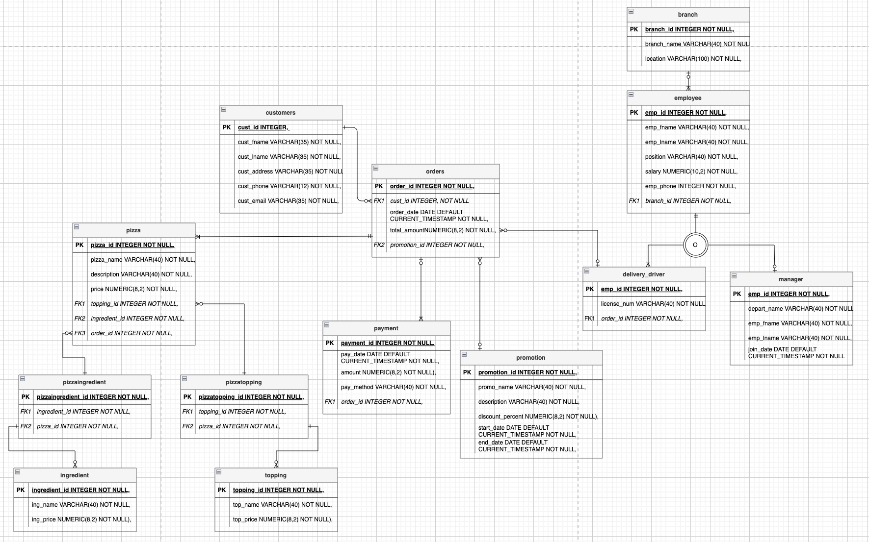

Figure 2 ERD Model

# **2. pgAdmin Screenshot**

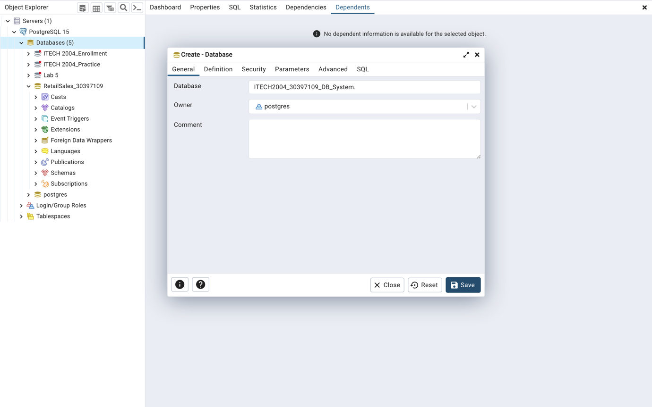

Figure 3 Database Creation Image 1

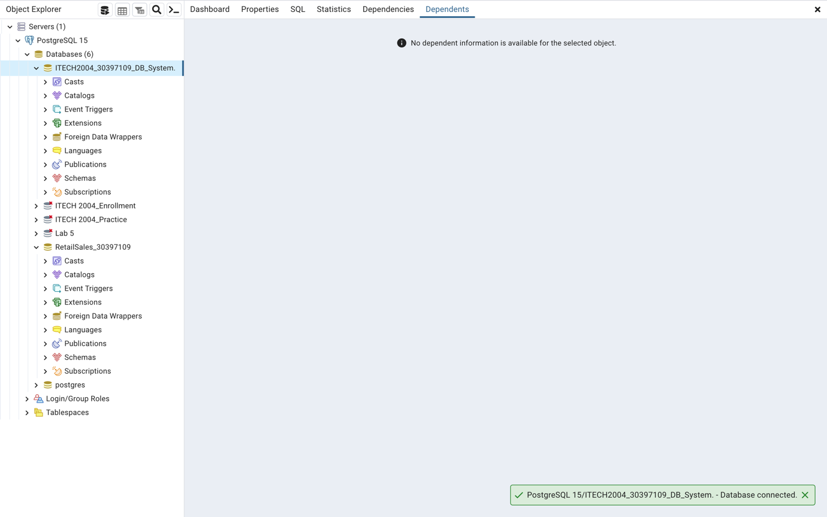

Figure 4 Database Creation Image 2

# **3. DDL Statements**

## **3.1 customer**

START TRANSACTION;

CREATE TABLE customer (

cust_id INTEGER,

cust_fname VARCHAR(35) NOT NULL,

cust_lname VARCHAR(35) NOT NULL,

cust_address VARCHAR(35) NOT NULL,

cust_phone VARCHAR(12) NOT NULL,

cust_email VARCHAR(35) NOT NULL,

PRIMARY KEY (cust_id),

CONSTRAINT cus_ui1 UNIQUE(cust_fname, cust_lname, cust_phone));

COMMIT;

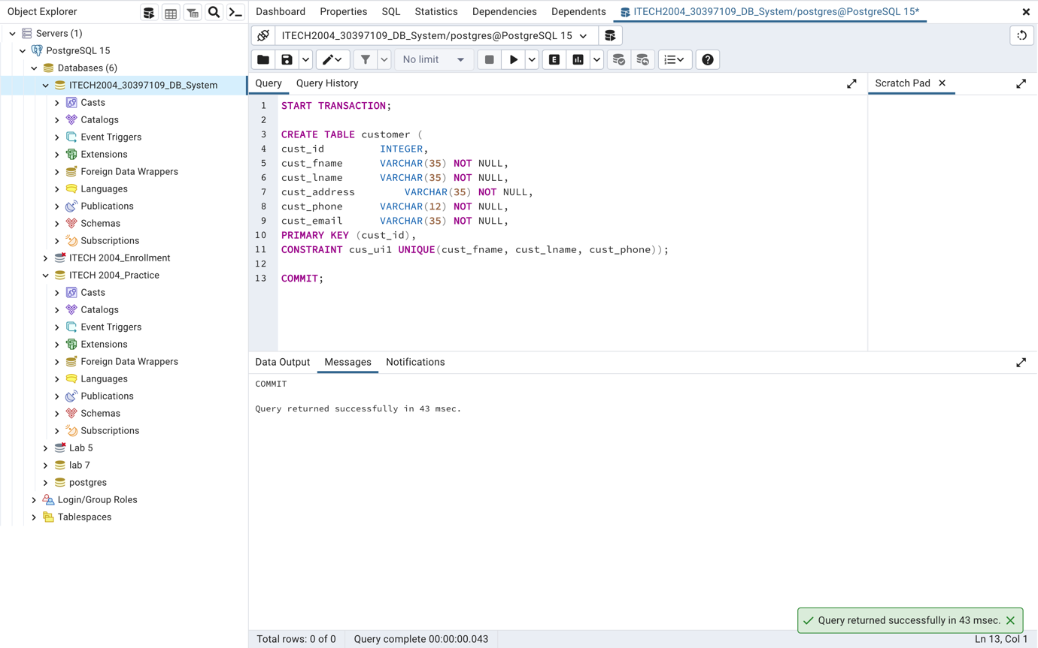

Figure 5 DDL for customer Table

## **3.2 promotion**

START TRANSACTION;

CREATE TABLE promotion (

promotion_id INTEGER NOT NULL,

promo_name VARCHAR(40) NOT NULL,

description VARCHAR(40) NOT NULL,

discount_percent NUMERIC(8,2) NOT NULL,

start_date DATE DEFAULT CURRENT_TIMESTAMP NOT NULL,

end_date DATE DEFAULT CURRENT_TIMESTAMP NOT NULL,

PRIMARY KEY (promotion_id));

COMMIT;

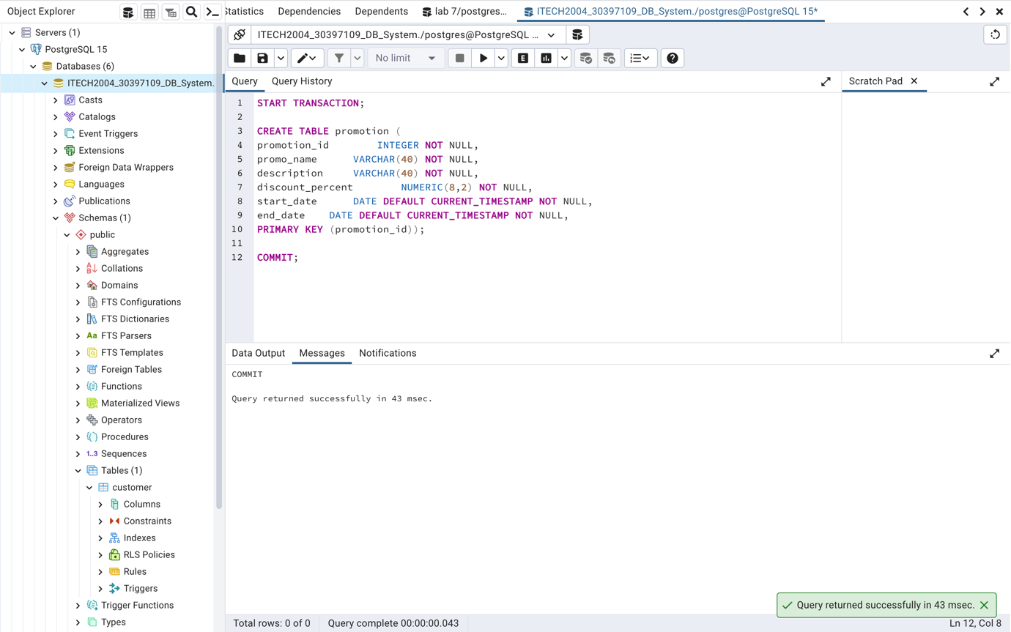

Figure 6 DDL for promotion Table

## **3.3 order**

START TRANSACTION;

CREATE TABLE "order" (

order_id INTEGER NOT NULL,

order_date DATE DEFAULT CURRENT_TIMESTAMP NOT NULL,

total_amount NUMERIC(8,2) NOT NULL,

cust_id INTEGER,

promotion_id INTEGER NOT NULL,

PRIMARY KEY (order_id),

FOREIGN KEY (cust_id) REFERENCES customer ON DELETE CASCADE,

FOREIGN KEY (promotion_id) REFERENCES promotion(promotion_id));

COMMIT;

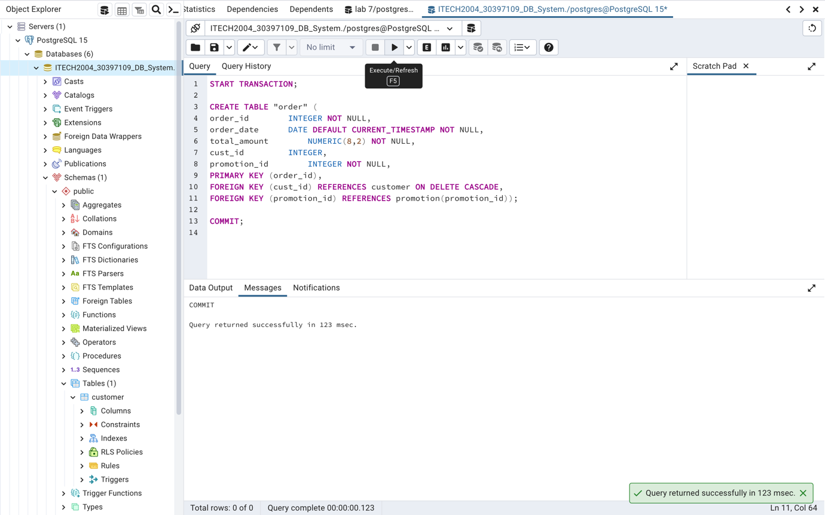

Figure 7 DDL for order Table

## **3.4 payment**

START TRANSACTION;

CREATE TABLE payment (

payment_id INTEGER NOT NULL,

pay_date DATE DEFAULT CURRENT_TIMESTAMP NOT NULL,

amount NUMERIC(8,2) NOT NULL,

pay_method VARCHAR(40) NOT NULL,

order_id INTEGER NOT NULL,

PRIMARY KEY (payment_id),

FOREIGN KEY (order_id) REFERENCES "order"(order_id));

COMMIT;

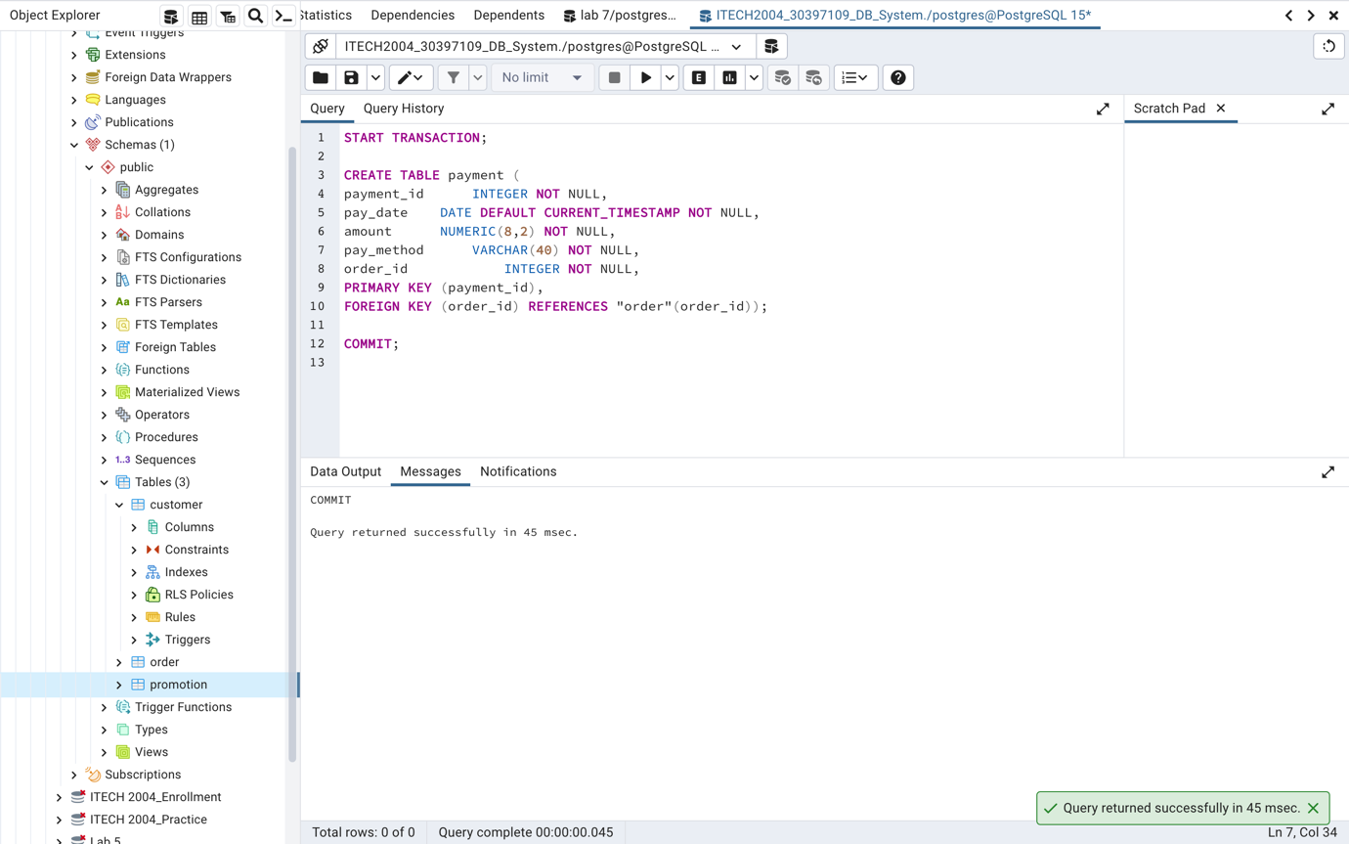

Figure 8 DDL for payment Table

## **3.5 ingredient**

START TRANSACTION;

CREATE TABLE ingredient (

ingredient_id INTEGER NOT NULL,

ing_name VARCHAR(40) NOT NULL,

ing_price NUMERIC(8,2) NOT NULL,

PRIMARY KEY (ingredient_id));

COMMIT;

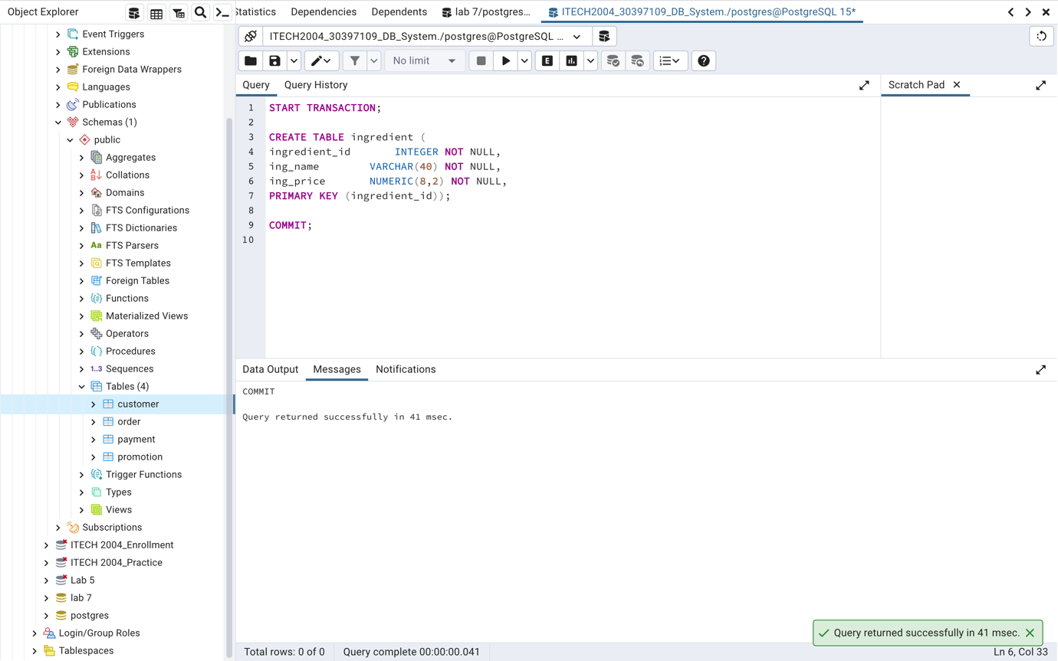

Figure 9 DDL for ingredient Table

## **3.6 topping**

START TRANSACTION;

CREATE TABLE topping (

topping_id INTEGER NOT NULL,

top_name VARCHAR(40) NOT NULL,

top_price NUMERIC(8,2) NOT NULL,

PRIMARY KEY (topping_id));

COMMIT;

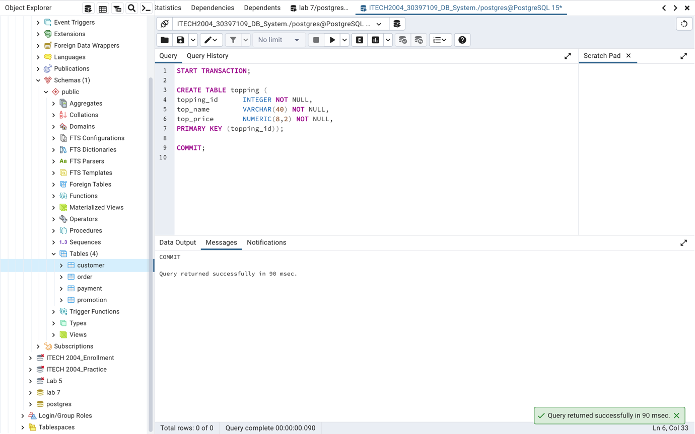

Figure 10 DDL for topping Table

## **3.7 pizza**

START TRANSACTION;

CREATE TABLE pizza (

pizza_id INTEGER NOT NULL,

pizza_name VARCHAR(40) NOT NULL,

description VARCHAR(40) NOT NULL,

price NUMERIC(8,2) NOT NULL,

topping_id INTEGER NOT NULL,

ingredient_id INTEGER NOT NULL,

order_id INTEGER NOT NULL,

PRIMARY KEY (pizza_id),

FOREIGN KEY (order_id) REFERENCES "order" ON DELETE CASCADE,

FOREIGN KEY (ingredient_id) REFERENCES ingredient(ingredient_id),

FOREIGN KEY (topping_id) REFERENCES topping(topping_id));

COMMIT;

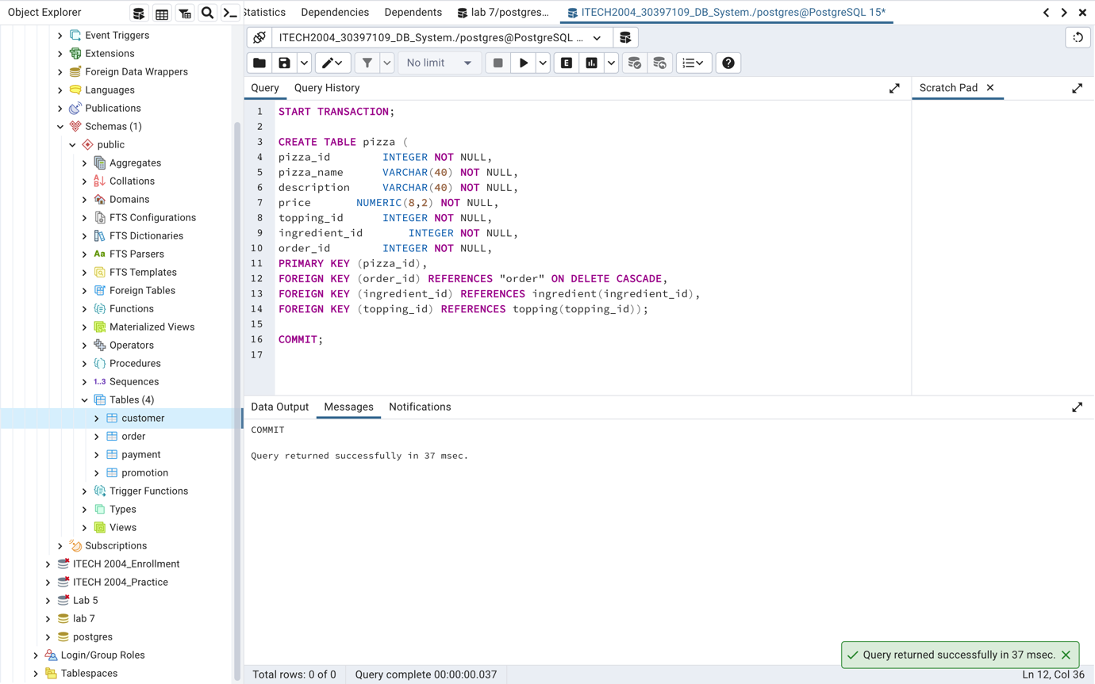

Figure 11 DDL for pizza Table

## **3.8 pizzatopping**

START TRANSACTION;

CREATE TABLE pizzatopping (

pizzatopping_id INTEGER NOT NULL,

topping_id INTEGER NOT NULL,

pizza_id INTEGER NOT NULL,

PRIMARY KEY (pizzatopping_id),

FOREIGN KEY (topping_id) REFERENCES topping(topping_id) ON DELETE CASCADE,

FOREIGN KEY (pizza_id) REFERENCES pizza(pizza_id) ON DELETE CASCADE);

COMMIT;

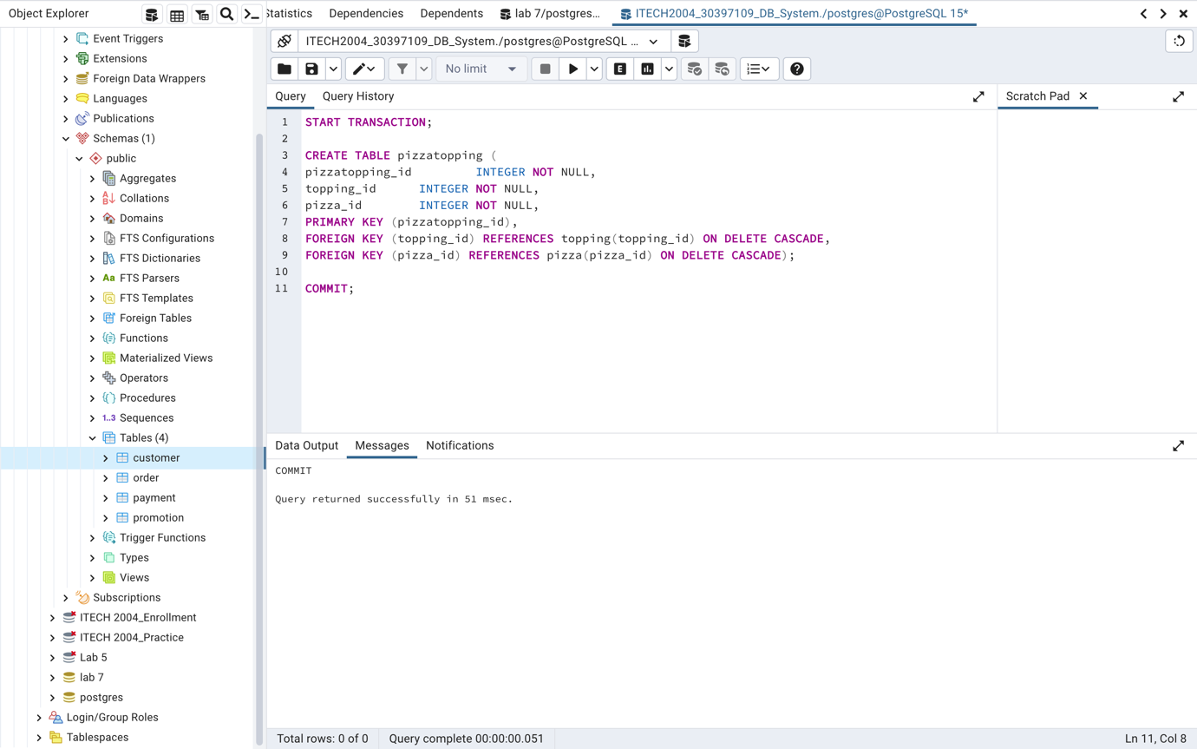

Figure 12 DDL for pizzatopping Table

## **3.9 pizzaingredient**

START TRANSACTION;

CREATE TABLE pizzaingredient (

pizzaingredient_id INTEGER NOT NULL,

ingredient_id INTEGER NOT NULL,

pizza_id INTEGER NOT NULL,

PRIMARY KEY (pizzaingredient_id),

FOREIGN KEY (pizza_id) REFERENCES pizza(pizza_id) ON DELETE CASCADE,

FOREIGN KEY (ingredient_id) REFERENCES ingredient(ingredient_id) ON DELETE CASCADE);

COMMIT;

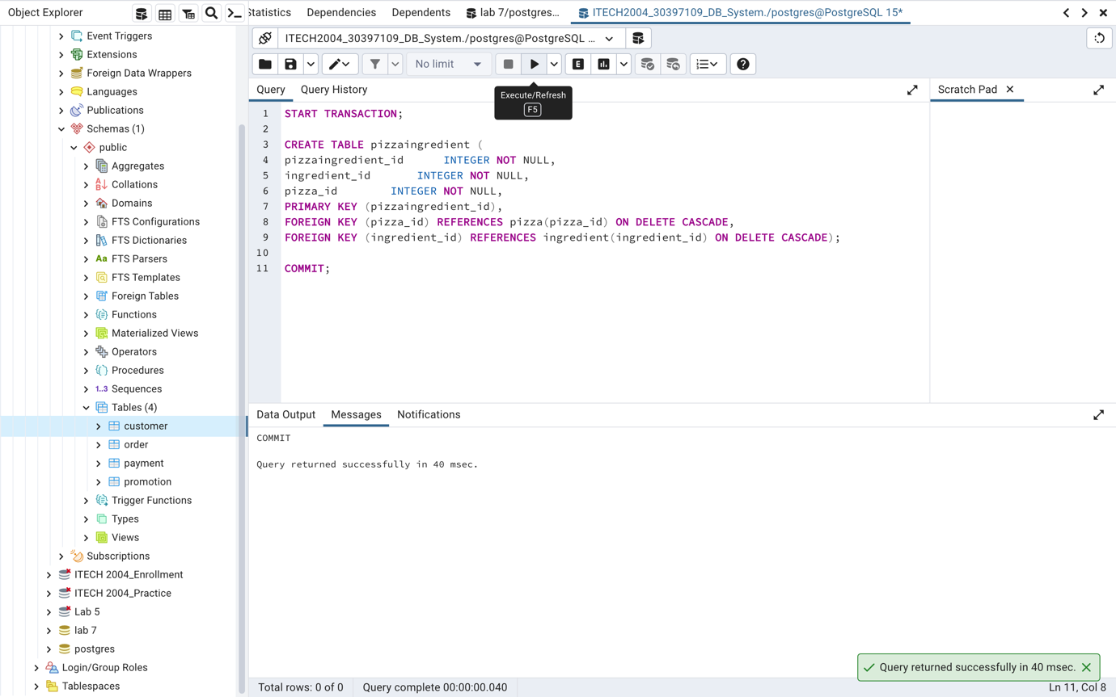

Figure 13 DDL for pizzaingredient Table

## **3.10 branch**

START TRANSACTION;

CREATE TABLE branch (

branch_id INTEGER NOT NULL,

branch_name VARCHAR(40) NOT NULL,

location VARCHAR(100) NOT NULL,

PRIMARY KEY (branch_id));

COMMIT;

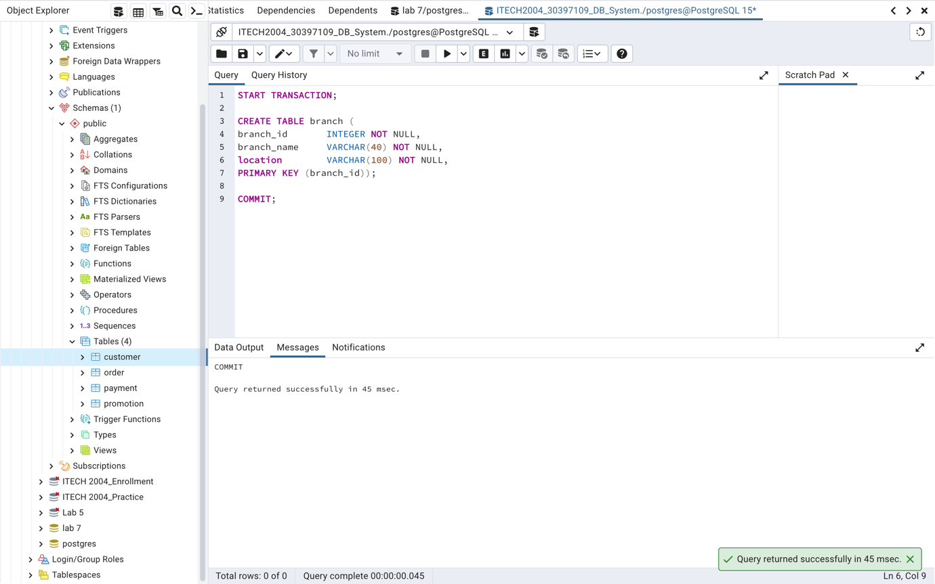

Figure 14 DDL for branch Table

## **3.11 employee**

START TRANSACTION;

CREATE TABLE employee (

emp_id INTEGER NOT NULL,

emp_fname VARCHAR(40) NOT NULL,

emp_lname VARCHAR(40) NOT NULL,

position VARCHAR(40) NOT NULL,

salary NUMERIC(10,2) NOT NULL,

emp_phone INTEGER NOT NULL,

branch_id INTEGER NOT NULL,

PRIMARY KEY (emp_id),

FOREIGN KEY (branch_id) REFERENCES branch ON DELETE CASCADE);

COMMIT;

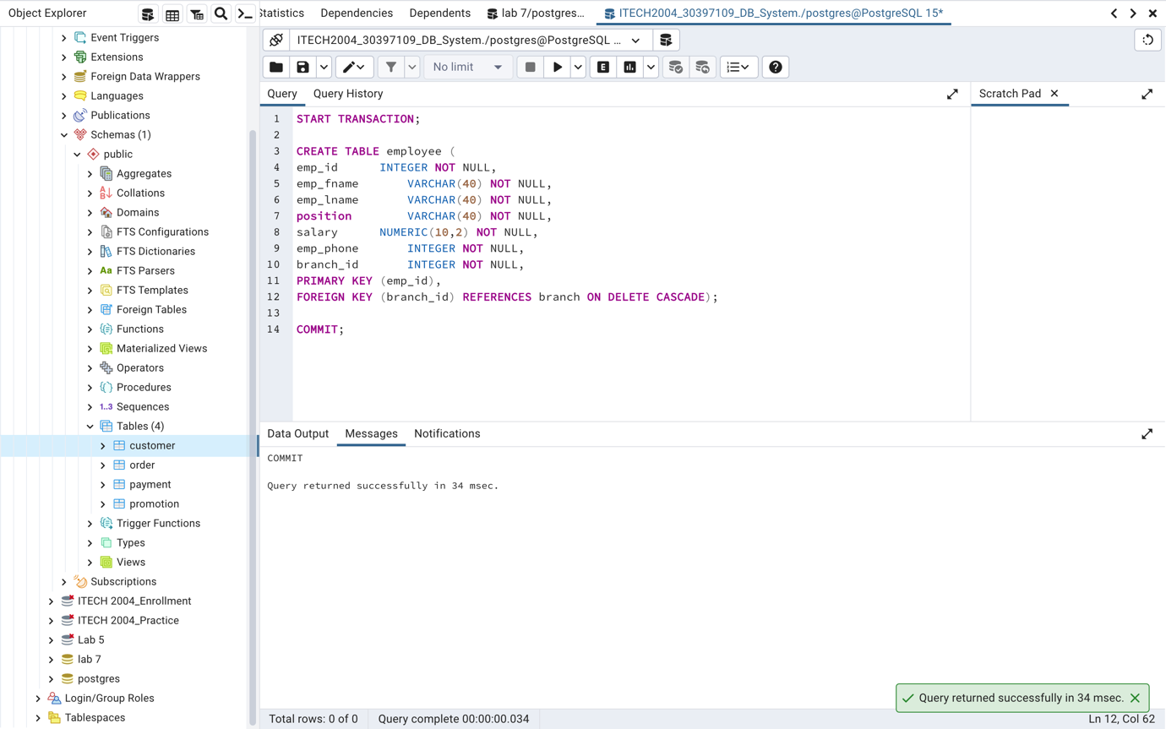

Figure 15 DDL for employee Table

## **3.12 delivery_driver**

START TRANSACTION;

CREATE TABLE delivery_driver (

emp_id INTEGER NOT NULL,

license_num VARCHAR(40) NOT NULL,

order_id INTEGER NOT NULL,

FOREIGN KEY (order_id) REFERENCES "order"(order_id));

COMMIT;

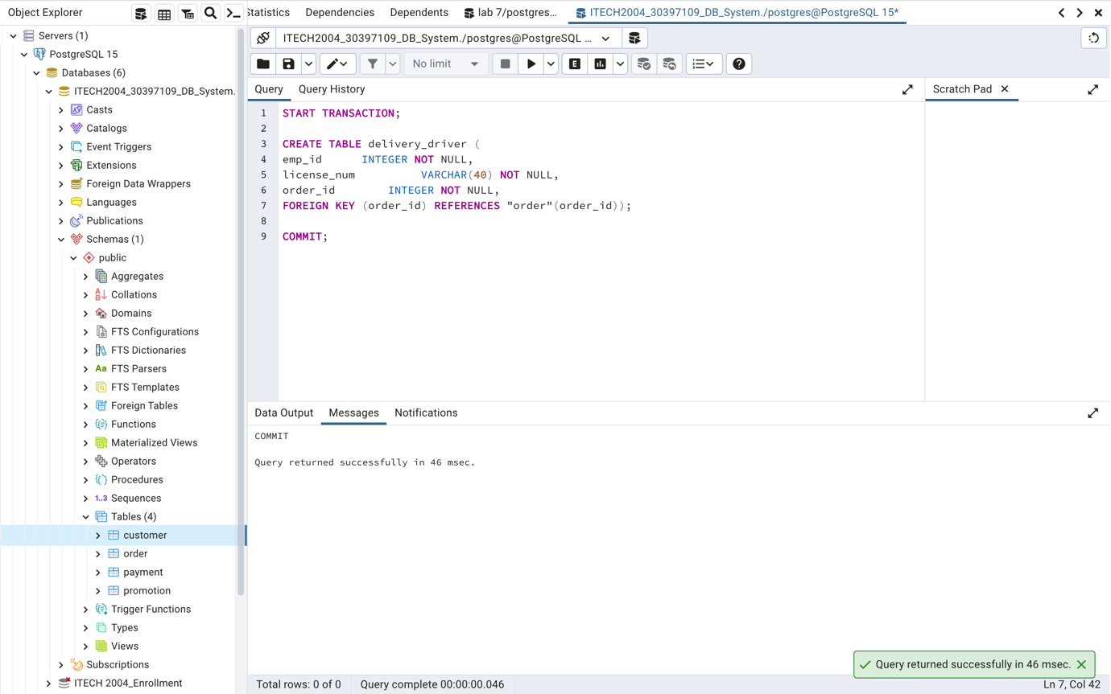

Figure 16 DDL for delivery_driver Table

## **3.13 manager**

START TRANSACTION;

CREATE TABLE manager (

emp_id INTEGER NOT NULL,

emp_fname VARCHAR(40) NOT NULL,

emp_lname VARCHAR(40) NOT NULL,

depart_name VARCHAR(40) NOT NULL,

join_date DATE DEFAULT CURRENT_TIMESTAMP NOT NULL);

COMMIT;

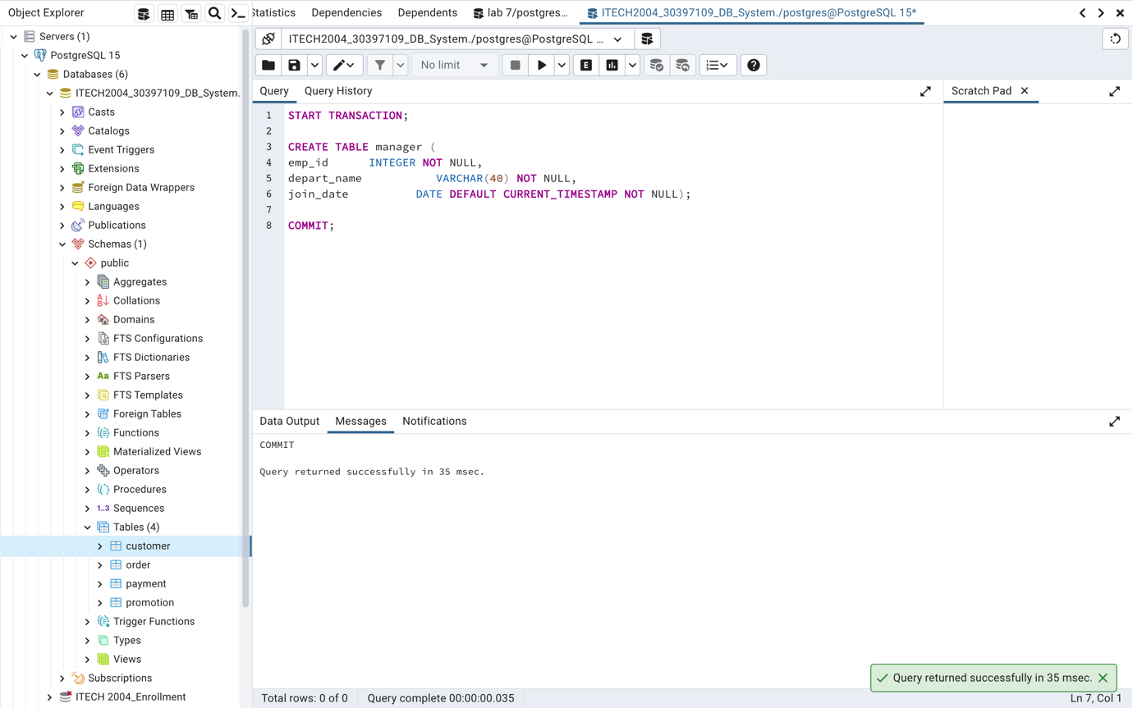

Figure 17 DDL for manager Table

# **4. DML Statements**

## **customer**

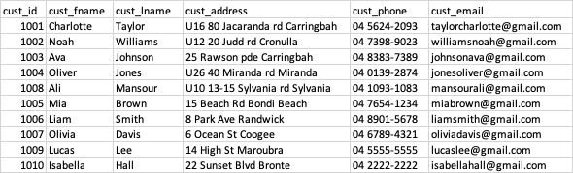

START TRANSACTION;

/* customer rows */

INSERT INTO customer VALUES(1001,'Charlotte','Taylor','U16 80 Jacaranda rd Carringbah','04 5624-2093','taylorcharlotte@gmail.com');

INSERT INTO customer VALUES(1002,'Noah','Williams','U12 20 Judd rd Cronulla','04 7398-9023','williamsnoah@gmail.com');

INSERT INTO customer VALUES(1003,'Ava','Johnson','25 Rawson pde Carringbah','04 8383-7389','johnsonava@gmail.com');

INSERT INTO customer VALUES(1004,'Oliver','Jones','U26 40 Miranda rd Miranda','04 0139-2874','jonesoliver@gmail.com');

INSERT INTO customer VALUES(1008,'Ali', 'Mansour','U10 13-15 Sylvania rd Sylvania','04 1093-1083','mansourali@gmail.com');

COMMIT;

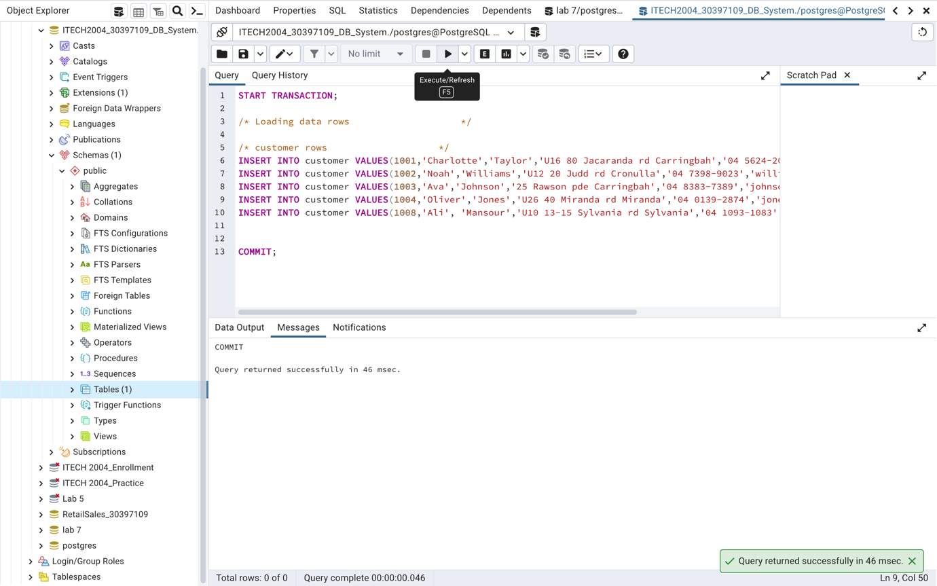

Figure 18 DML for customer Table

## **promotion**

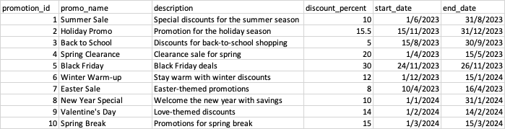

START TRANSACTION;

/* promotion rows */

INSERT INTO promotion VALUES(1, 'Summer Sale', 'Special discounts for the summer season', 10.00, '2023-06-01', '2023-08-31');

INSERT INTO promotion VALUES(2, 'Holiday Promo', 'Promotion for the holiday season', 15.50, '2023-11-15', '2023-12-31');

INSERT INTO promotion VALUES(3, 'Back to School', 'Discounts for back-to-school shopping', 5.00, '2023-08-15', '2023-09-30');

INSERT INTO promotion VALUES(4, 'Spring Clearance', 'Clearance sale for spring', 20.00, '2023-04-01', '2023-05-15');

INSERT INTO promotion VALUES(5, 'Black Friday', 'Black Friday deals', 30.00, '2023-11-24', '2023-11-26');

COMMIT;

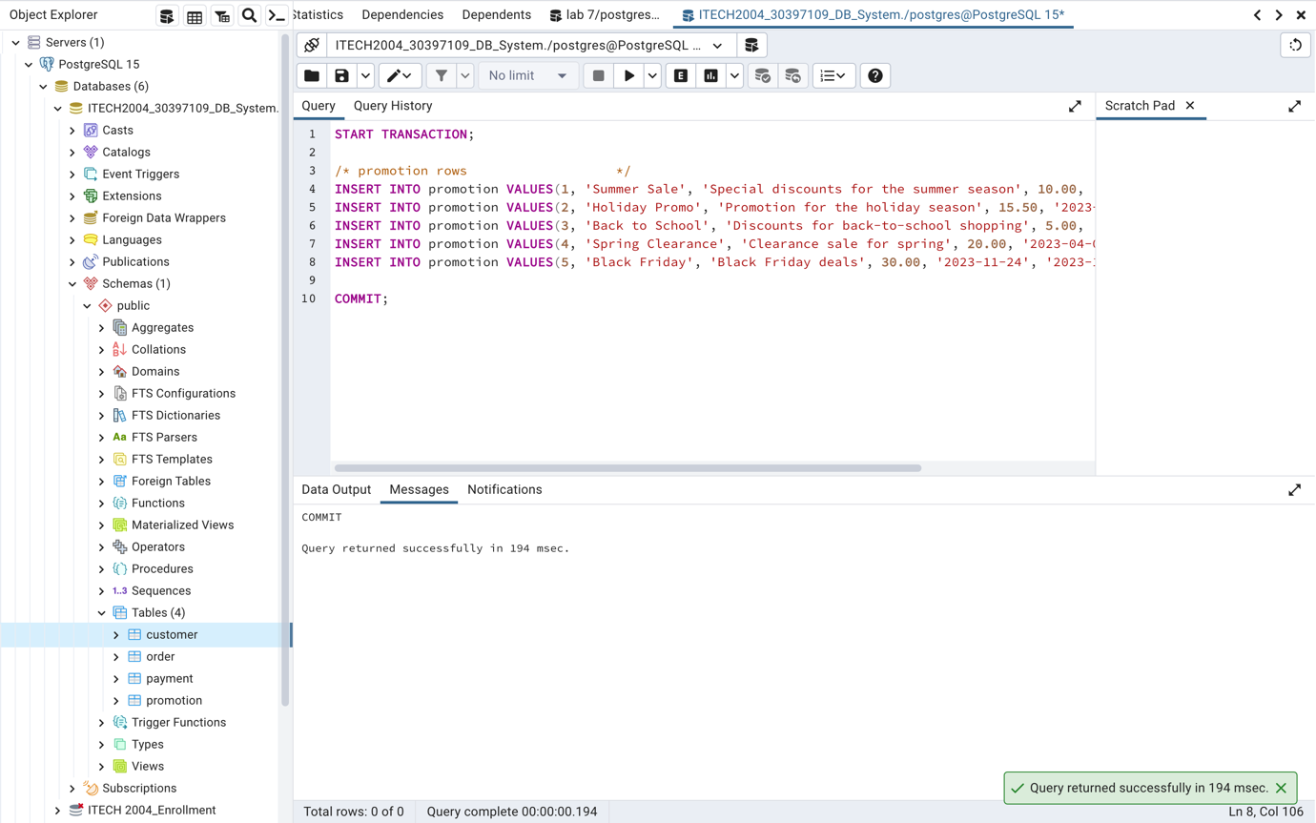

Figure 19 DML for promotion Table

## **order**

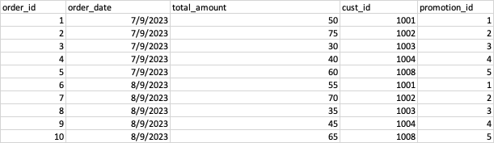

START TRANSACTION;

/* order rows */

INSERT INTO "order" VALUES(120, '2023-09-07', 50.00, 1001, 1);

INSERT INTO "order" VALUES(121, '2023-09-07', 75.00, 1002, 2);

INSERT INTO "order" VALUES(123, '2023-09-07', 30.00, 1003, 3);

INSERT INTO "order" VALUES(124, '2023-09-07', 40.00, 1004, 4);

INSERT INTO "order" VALUES(125, '2023-09-07', 60.00, 1008, 5);

COMMIT;

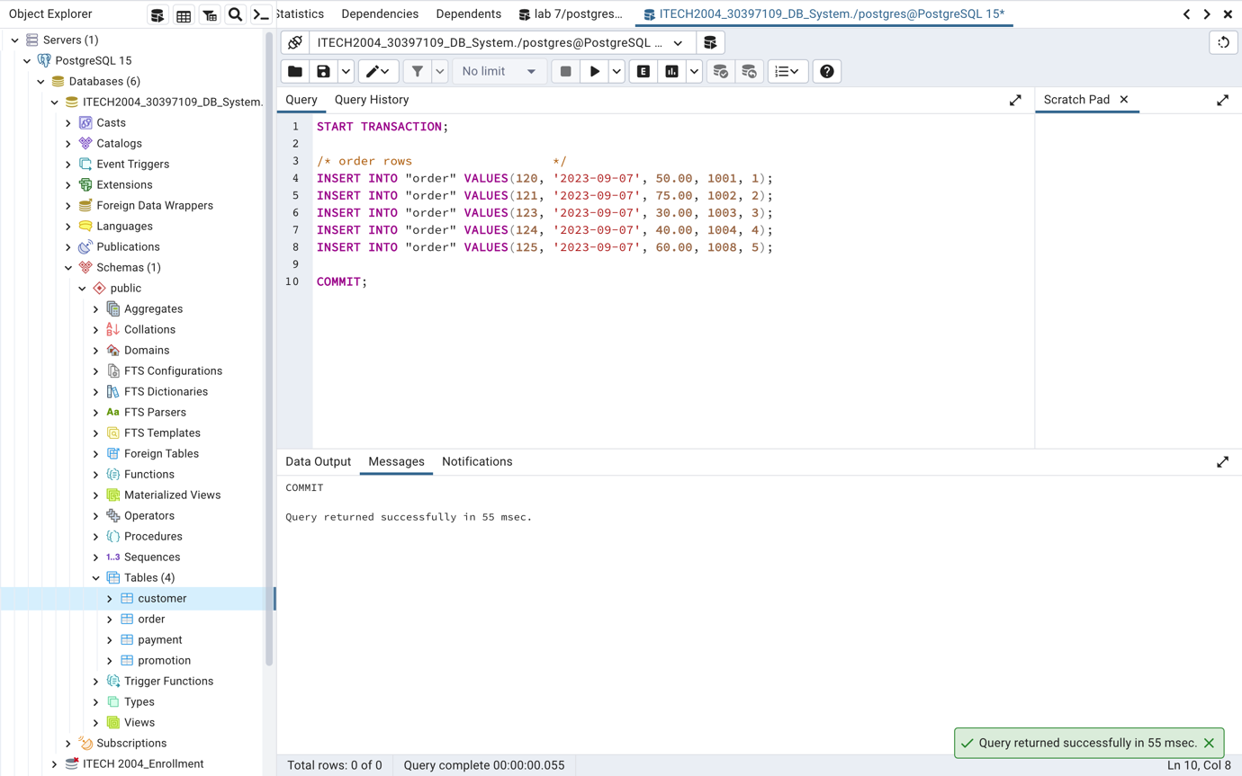

Figure 20 DML for order Table

## **payment**

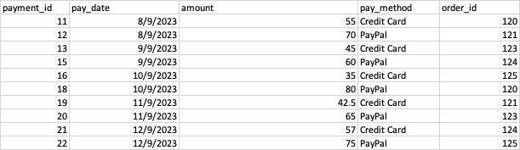

START TRANSACTION;

/* payment rows */

INSERT INTO payment VALUES(11, '2023-09-08', 55.00, 'Credit Card', 120);

INSERT INTO payment VALUES(12, '2023-09-08', 70.00, 'PayPal', 121);

INSERT INTO payment VALUES(13, '2023-09-09', 45.00, 'Credit Card', 123);

INSERT INTO payment VALUES(15, '2023-09-09', 60.00, 'PayPal', 124);

INSERT INTO payment VALUES(16, '2023-09-10', 35.00, 'Credit Card', 125);

COMMIT;

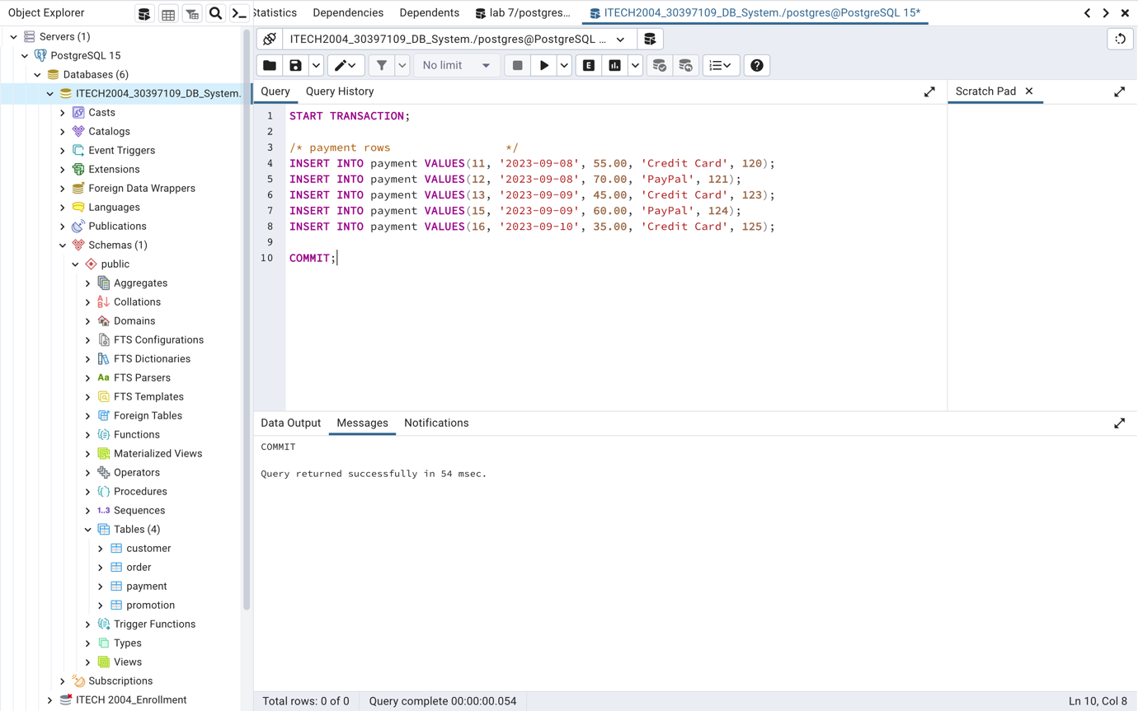

Figure 21 DML for payment Table

## **ingredient**

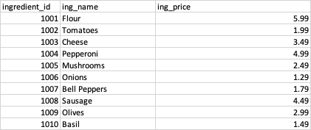

START TRANSACTION;

/* ingredient rows */

INSERT INTO ingredient VALUES(1001, 'Flour', 5.99);

INSERT INTO ingredient VALUES(1002, 'Tomatoes', 1.99);

INSERT INTO ingredient VALUES(1003, 'Cheese', 3.49);

INSERT INTO ingredient VALUES(1004, 'Pepperoni', 4.99);

INSERT INTO ingredient VALUES(1005, 'Mushrooms', 2.49);

COMMIT;

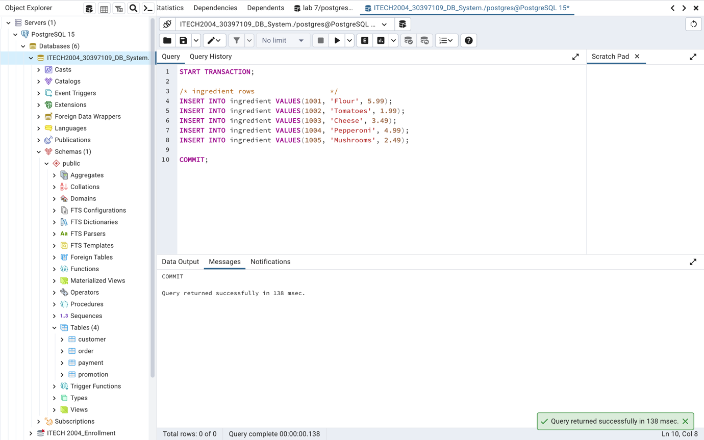

Figure 22 DML for ingredient Table

## **topping**

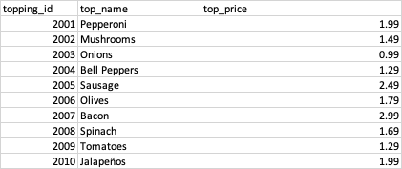

START TRANSACTION;

/* topping rows */

INSERT INTO topping VALUES(2003, 'Onions', 0.99);

INSERT INTO topping VALUES(2004, 'Bell Peppers', 1.29);

INSERT INTO topping VALUES(2005, 'Sausage', 2.49);

INSERT INTO topping VALUES(2008, 'Spinach', 1.69);

INSERT INTO topping VALUES(2010, 'Jalapeños', 1.99);

COMMIT;

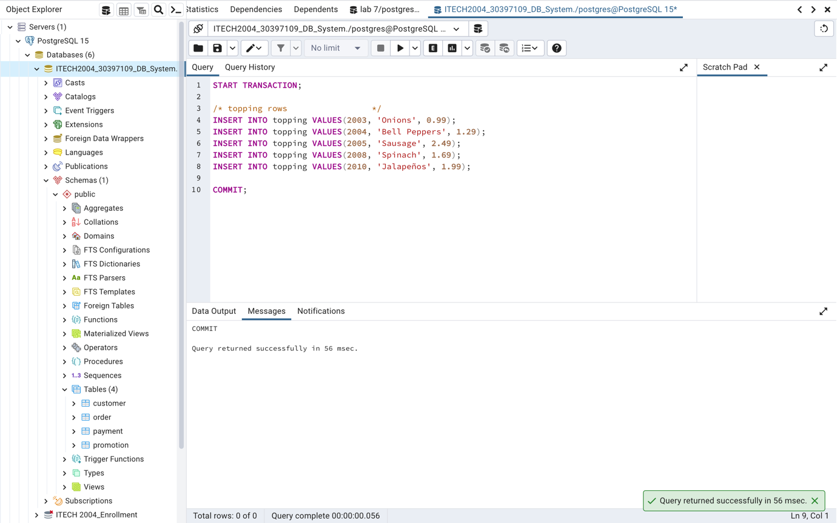

Figure 23 DML for topping Table

## **pizza**

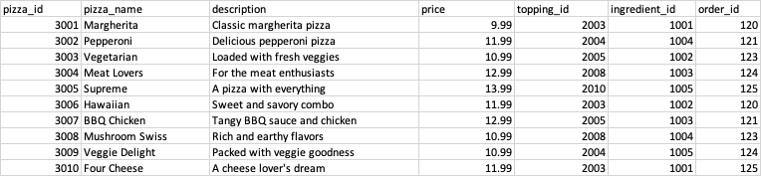

START TRANSACTION;

/* pizza rows */

INSERT INTO pizza VALUES(3001, 'Margherita', 'Classic margherita pizza', 9.99, 2003, 1001, 120);

INSERT INTO pizza VALUES(3002, 'Pepperoni', 'Delicious pepperoni pizza', 11.99, 2004, 1004, 121);

INSERT INTO pizza VALUES(3003, 'Vegetarian', 'Loaded with fresh veggies', 10.99, 2005, 1002, 123);

INSERT INTO pizza VALUES(3004, 'Meat Lovers', 'For the meat enthusiasts', 12.99, 2008, 1003, 124);

INSERT INTO pizza VALUES(3005, 'Supreme', 'A pizza with everything', 13.99, 2010, 1005, 125);

COMMIT;

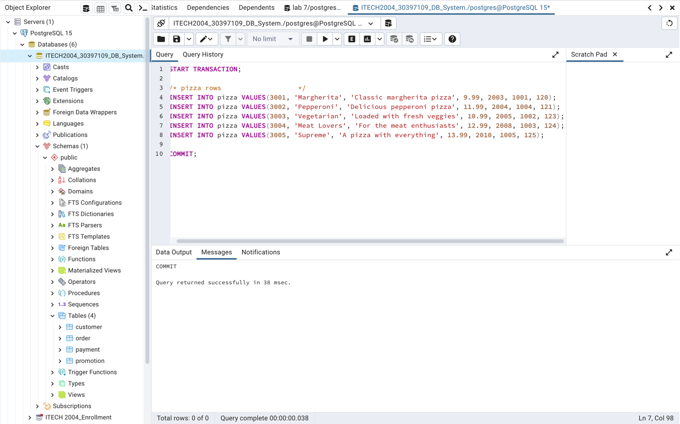

Figure 24 DML for pizza Table

## **pizzatopping**

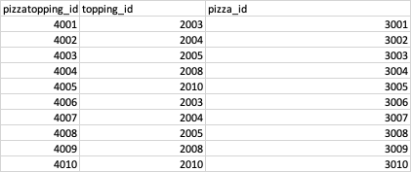

START TRANSACTION;

/* pizzatopping rows */

INSERT INTO pizzatopping VALUES(4001, 2003, 3001);

INSERT INTO pizzatopping VALUES(4002, 2004, 3002);

INSERT INTO pizzatopping VALUES(4003, 2005, 3003);

INSERT INTO pizzatopping VALUES(4004, 2008, 3004);

INSERT INTO pizzatopping VALUES(4005, 2010, 3005);

COMMIT;

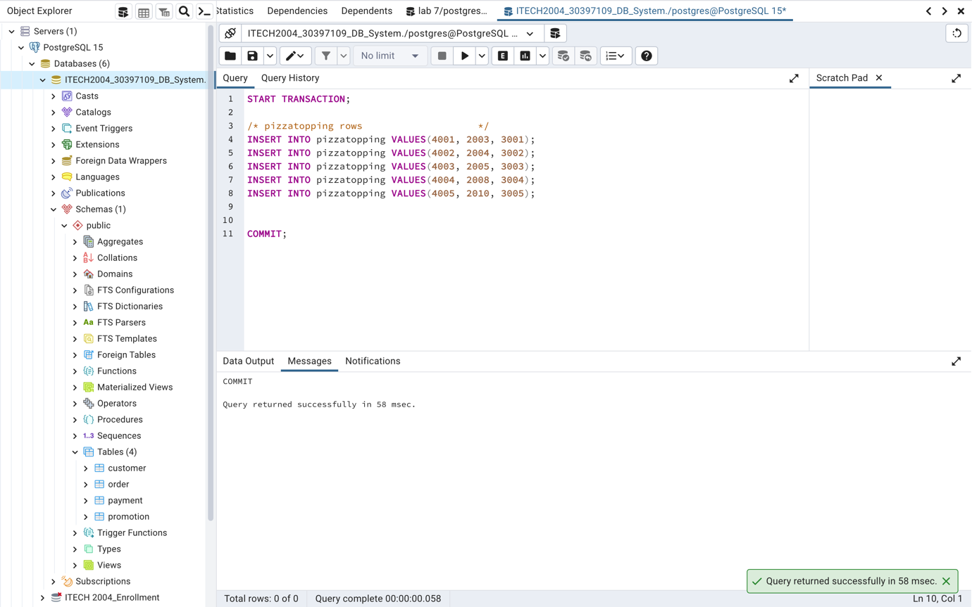

Figure 25 DML for pizzatopping Table

## **pizzaingredient**

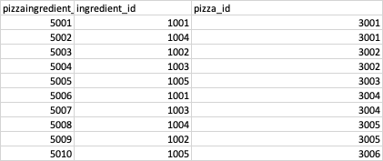

START TRANSACTION;

/* pizzaingredient rows */

INSERT INTO pizzaingredient VALUES(5001, 1001, 3001);

INSERT INTO pizzaingredient VALUES(5002, 1004, 3001);

INSERT INTO pizzaingredient VALUES(5003, 1002, 3002);

INSERT INTO pizzaingredient VALUES(5004, 1003, 3002);

INSERT INTO pizzaingredient VALUES(5005, 1005, 3003);

COMMIT;

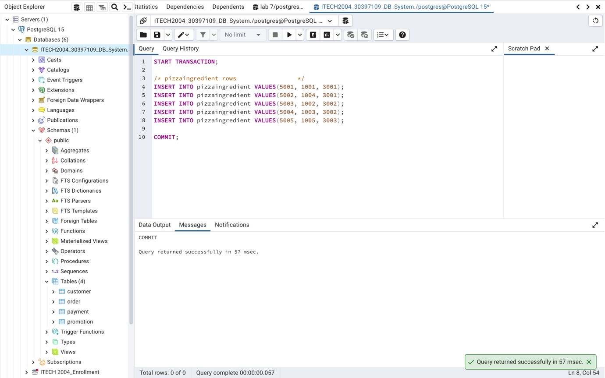

Figure 26 DML for pizzaingredient Table

## **branch**

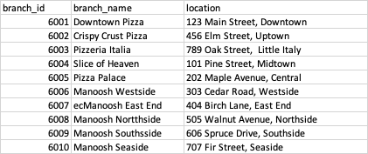

START TRANSACTION;

/* branch rows */

INSERT INTO branch VALUES(6001, 'Downtown Pizza', '123 Main Street, Downtown');

INSERT INTO branch VALUES(6002, 'Crispy Crust Pizza', '456 Elm Street, Uptown');

INSERT INTO branch VALUES(6003, 'Pizzeria Italia', '789 Oak Street, Little Italy');

INSERT INTO branch VALUES(6004, 'Slice of Heaven', '101 Pine Street, Midtown');

INSERT INTO branch VALUES(6005, 'Pizza Palace', '202 Maple Avenue, Central');

COMMIT;

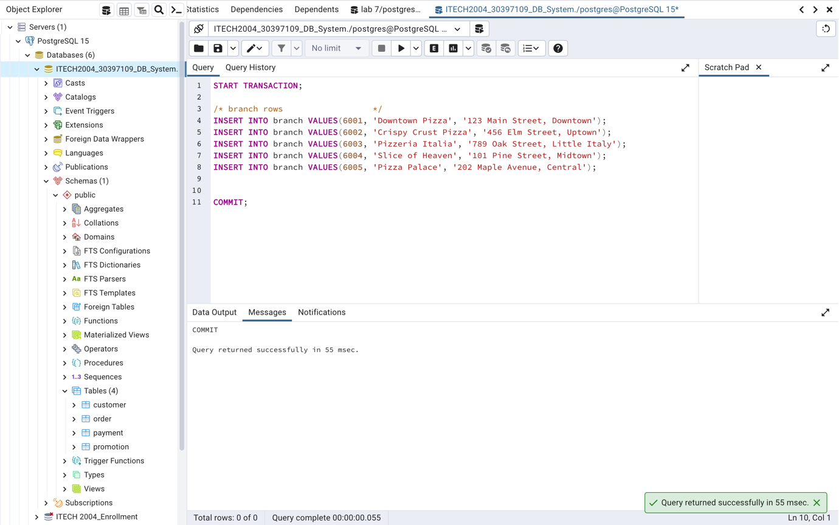

Figure 27 DML for branch Table

## **employee**

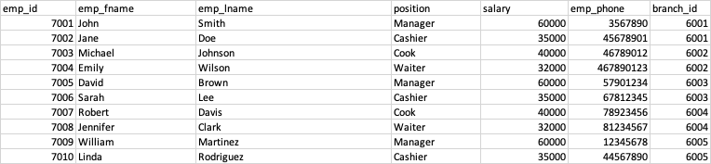

START TRANSACTION;

/* employee rows */

INSERT INTO employee VALUES(7001, 'John', 'Smith', 'Manager', 60000.00, 3567890, 6001);

INSERT INTO employee VALUES(7002, 'Jane', 'Doe', 'Cashier', 35000.00, 45678901, 6001);

INSERT INTO employee VALUES(7003, 'Michael', 'Johnson', 'Cook', 40000.00, 46789012, 6002);

INSERT INTO employee VALUES(7004, 'Emily', 'Wilson', 'Waiter', 32000.00, 467890123, 6002);

INSERT INTO employee VALUES(7005, 'David', 'Brown', 'Manager', 60000.00, 57901234, 6003);

COMMIT;

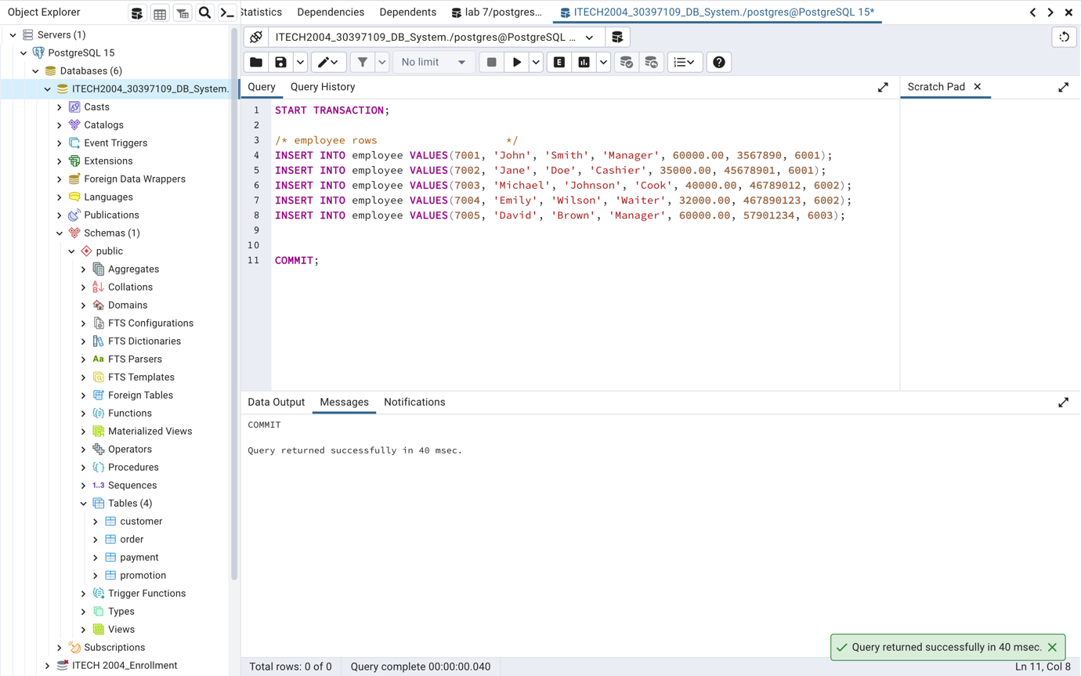

Figure 28 DML for employee Table

## **delivery_driver**

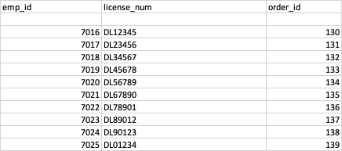

START TRANSACTION;

/* delivery_driver rows */

INSERT INTO delivery_driver VALUES(7006, 'DL12345', 120);

INSERT INTO delivery_driver VALUES(7007, 'DL23456', 121);

INSERT INTO delivery_driver VALUES(7008, 'DL34567', 123);

INSERT INTO delivery_driver VALUES(7009, 'DL45678', 124);

INSERT INTO delivery_driver VALUES(7010, 'DL45678', 125);

COMMIT;

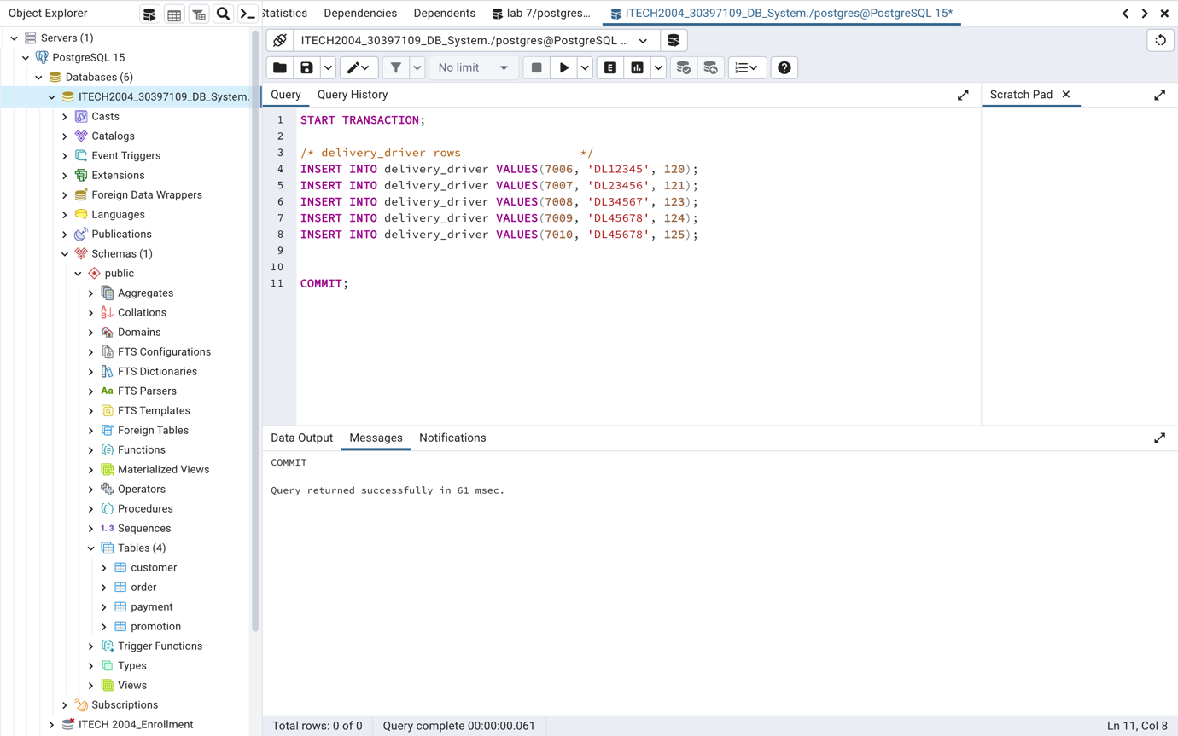

Figure 29 DML for delivery_driver Table

## **manager**

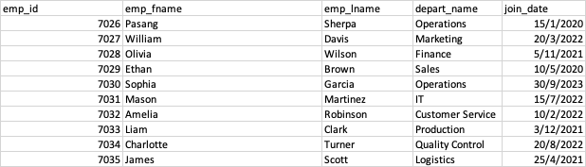

START TRANSACTION;

/* manager rows */

INSERT INTO manager VALUES (7026, 'Pasang', 'Sherpa', 'Operations','2020-01-15');

INSERT INTO manager VALUES (7027, 'William', 'Davis', 'Marketing','2022-03-20');

INSERT INTO manager VALUES (7028, 'Olivia', 'Wilson', 'Finance','2021-11-05');

INSERT INTO manager VALUES (7029, 'Ethan', 'Brown', 'Sales','2020-05-10');

INSERT INTO manager VALUES (7030, 'Sophia', 'Garcia', 'Operations','2023-09-30');

COMMIT;

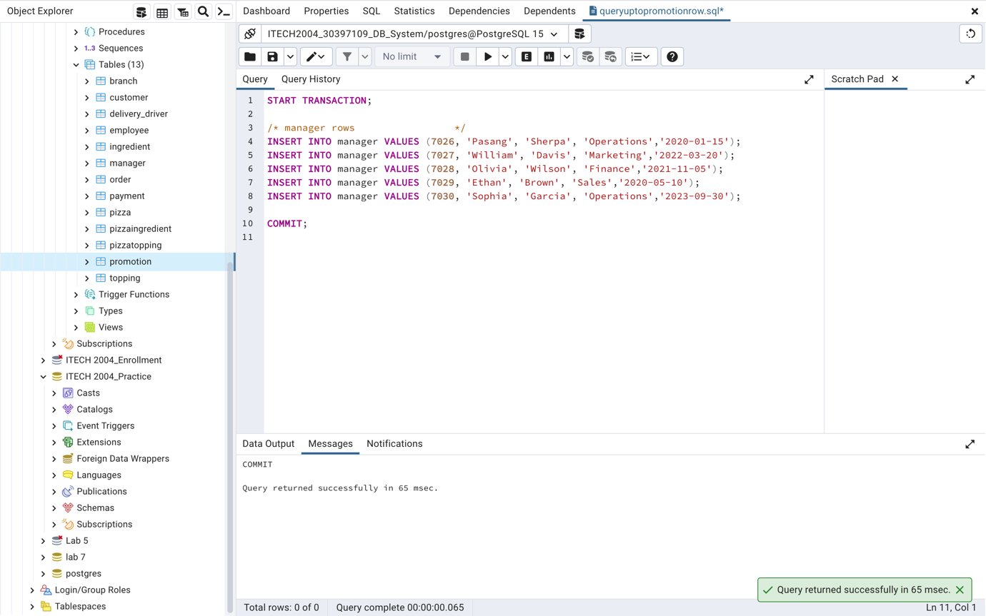

Figure 30 DML for manager Table

# **5. Queries and Results**

## **Query 1: Using INNER JOIN**

START TRANSACTION;

SELECT

"order".order_id,

customer.cust_fname,

customer.cust_lname,

"order".order_date,

"order".total_amount

FROM

"order" AS "order"

INNER JOIN

customer AS customer

ON

"order".cust_id = customer.cust_id;

COMMIT;

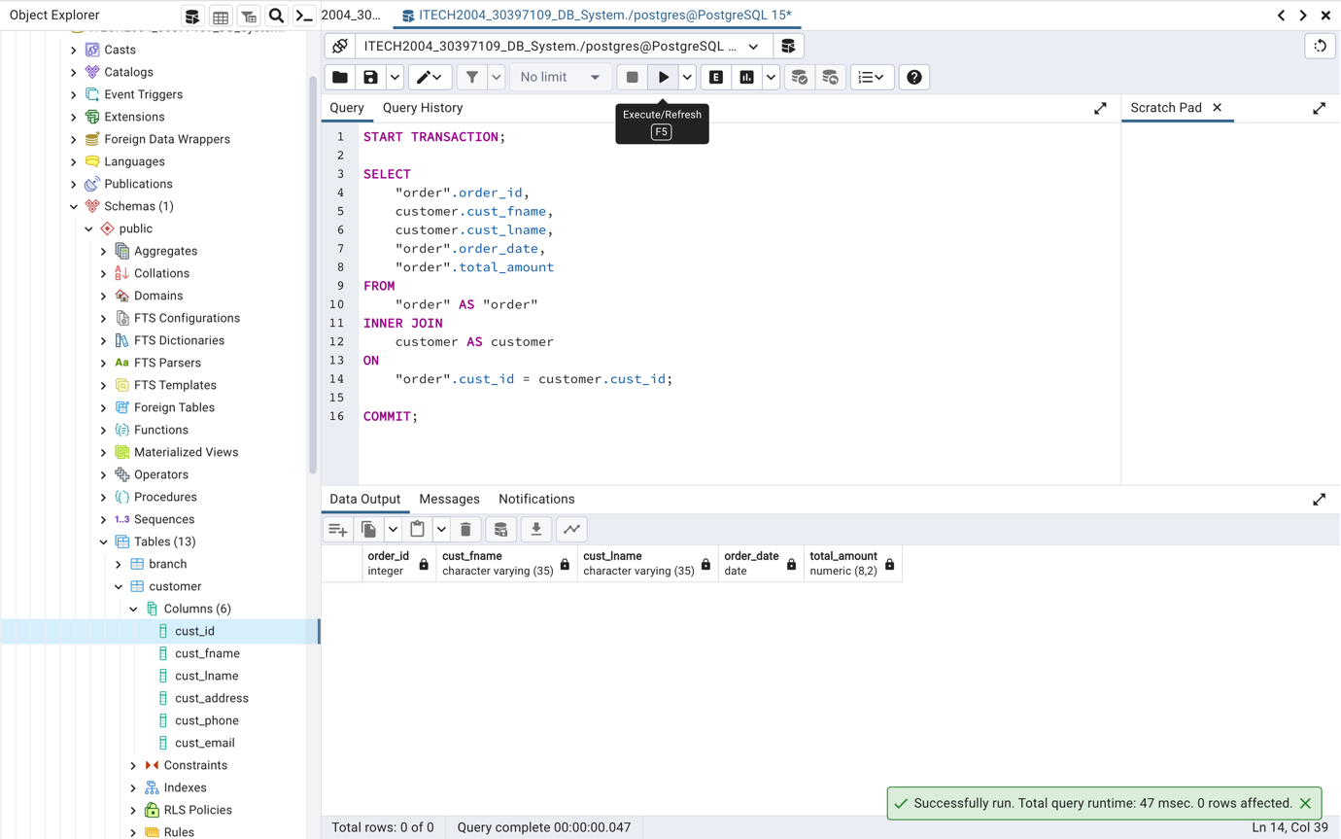

Figure 31 Query 1

**Explanation**:

By combining the "order" and "customer" columns using the shared cust_id column, this SQL query obtains a list of customer orders as well as customer information. In addition to the order ID, customer names, order dates, and total order amounts, it offers a thorough view of all customer orders.

## **Query 2: Using OUTER JOIN**

START TRANSACTION;

SELECT

customer.cust_id,

customer.cust_fname,

customer.cust_lname,

customer.cust_address,

customer.cust_phone,

customer.cust_email,

"order".order_id,

"order".order_date,

"order".total_amount

FROM

customer

LEFT OUTER JOIN

"order" ON customer.cust_id = "order".cust_id;

COMMIT;

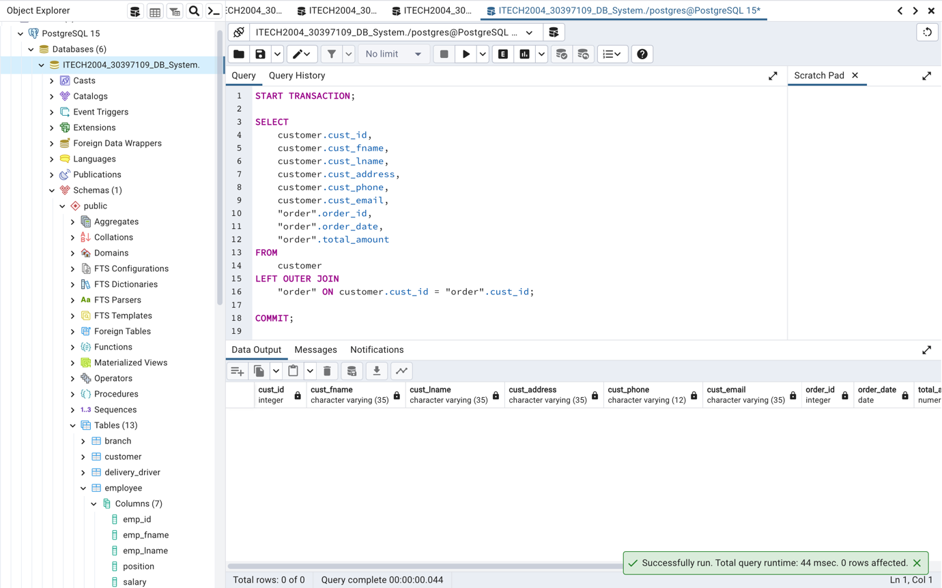

Figure 32 Query 2

**Explanation**:

Columns from the order and customer tables are being chosen. Even in cases when there are no orders (NULL values for order-related columns), we employ an LEFT OUTER JOIN to combine results from the customer table with matching rows from the order table. Customers and any connected orders, including those who haven't placed orders, will be shown in this query.

## **Query 3: Using Specialization Hierarchy**

START TRANSACTION;

SELECT

emp_id,

emp_fname,

emp_lname,

position

FROM

employee

UNION ALL

SELECT

emp_id,

emp_fname,

emp_lname,

depart_name AS position

FROM

manager;

COMMIT;

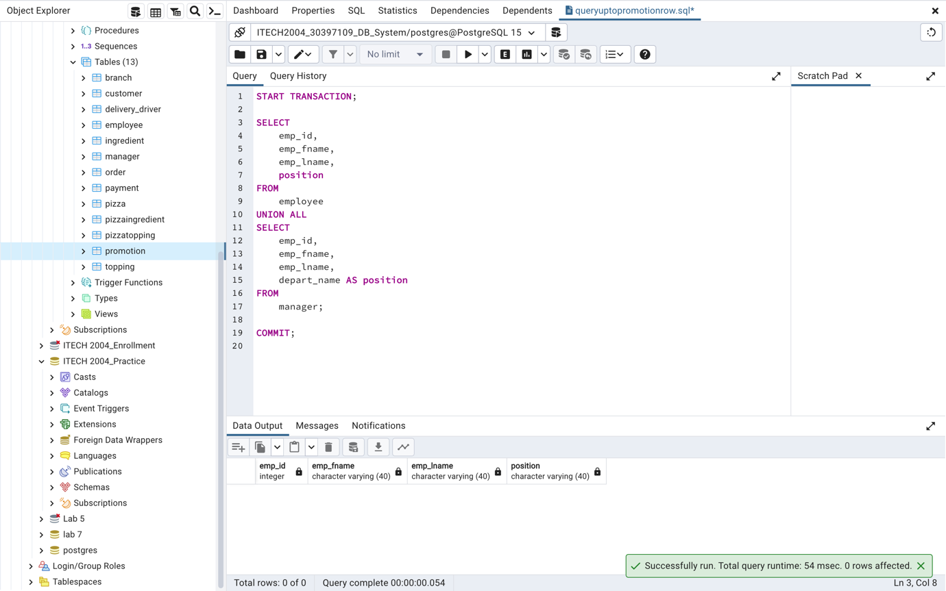

Figure 33 Query 3

**Explanation**:

The results of two SELECT queries are being combined using the UNION ALL operator. In the first query, information from the employee table is retrieved, including traits that apply to all employees. The second query obtains information from the manager table, which depicts an employee's area of specialisation. The same columns are returned by both queries: emp_id, emp_fname, emp_lname, and position. A comprehensive list of all employees, including managers, is provided by this query.

## **Query 4: Using GROUP BY and HAVING**

START TRANSACTION;

SELECT

customer.cust_id,

cust_fname,

cust_lname,

SUM(total_amount) AS total_order_amount

FROM

customer

INNER JOIN

"order" ON customer.cust_id = "order".cust_id

GROUP BY

customer.cust_id,

cust_fname,

cust_lname

HAVING

SUM(total_amount) > 50;

COMMIT;

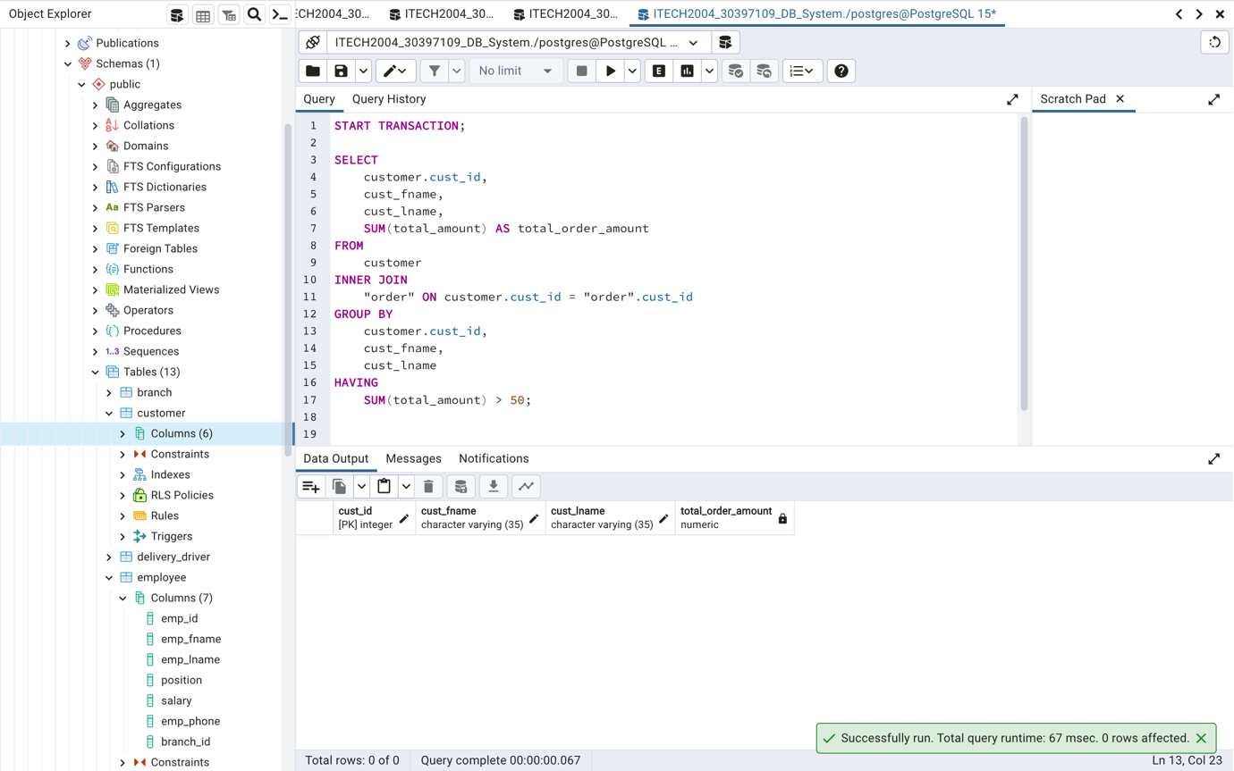

Figure 34 Query 4

**Explanation**:

Using the cust_id foreign key, we are linking the customer and order tables.In order to group the results by customers and determine the total order amount for each client, we utilise the GROUP BY command. The HAVING condition limits the results to clients with orders totalling more than $50.

## **Query 5: Using INNER SQL Query**

START TRANSACTION;

SELECT

cust_id,

cust_fname,

cust_lname,

cust_address,

cust_phone,

cust_email

FROM

customer

WHERE

cust_id IN (SELECT DISTINCT cust_id FROM "order");

COMMIT;

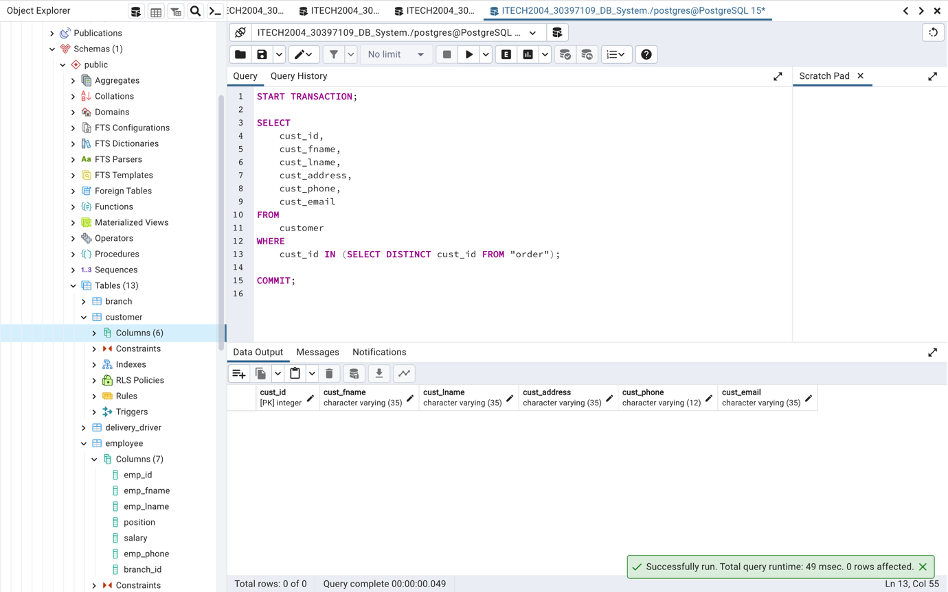

Figure 35 Query 5

**Explanation**:  
From the customer table, we are choosing customer data. A list of unique customer IDs is retrieved from the order table using the INNER SQL statement (SELECT DISTINCT cust_id FROM "order"). Checking whether a customer's cust_id is on the list of customer IDs from the subquery is how the main query screens customers. This query returns information about customers who have made orders.

## **Query 6: Using UPDATE**

START TRANSACTION;

UPDATE

employee

SET

position = 'Senior Cashier'

WHERE

position = 'Cashier';

COMMIT;

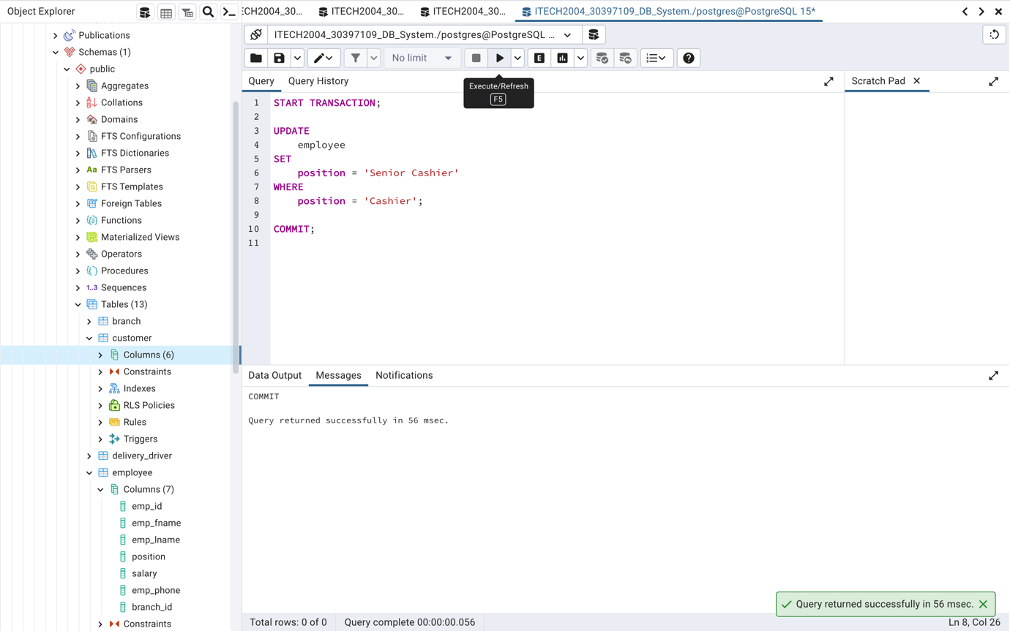

Figure 36 Query 6

**Explanation**:

The UPDATE statement is being used to change data in the employee table. For rows where the current position is "Cashier," we change the position column to "Senior Cashier." This query modifies the employee positions.

# **References**

Zainurrohman, A. (2021, 04 18). *Subtypes and Supertypes*. Retrieved from medium.com: https://medium.com/nerd-for-tech/subtypes-and-supertypes-ef3b6b37c250